Project Design Phase-II
Technology Stack (Architecture & Stack)
Date | 18 june 2026
Team ID
Project Name | HOUSE RENT
Maximum Marks | 4 Marks

Technical Architecture:
The deliverables shall include the House Hunt Solution Architecture Diagram, Table 1 (Functional Requirements), and Table 2 (Non-Functional Requirements).
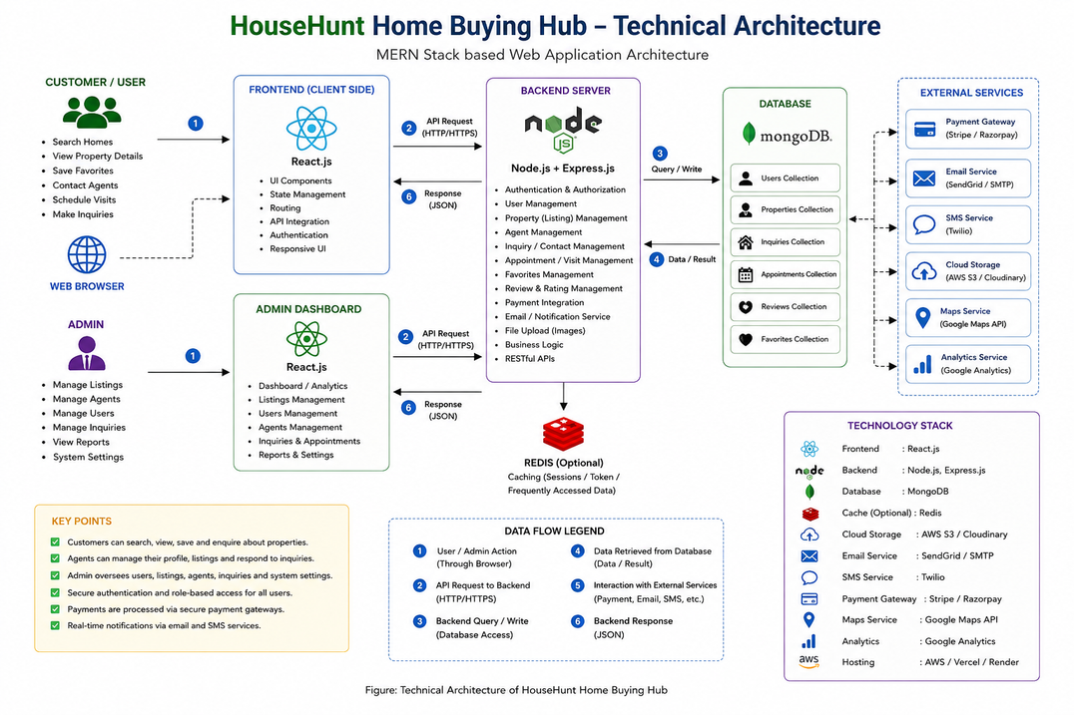

Table-1: Components & Technologies – House Hunt
S.No | Component | Description | Technology
1 | User Interface | Provides the interface for users and administrators to interact with the application. | HTML, CSS, JavaScript, React.js
2 | Application Logic-1 | Handles user registration, authentication, authorization, and account management. | Node.js, Express.js, JWT
3 | Application Logic-2 | Handles property listing, search, filtering, and favorites management. | Node.js, Express.js
4 | Application Logic-3 | Handles inquiry management and admin functionalities. | Node.js, Express.js
5 | Database | Stores users, properties, favorites, and inquiry information. | MongoDB Atlas, Mongoose
6 | Cloud Database | Cloud-hosted database service for storing application data. | MongoDB Atlas
7 | File Storage | Stores property images and static assets. | Image URLs / Cloud Storage
8 | External API-1 | API communication between frontend and backend services. | RESTful APIs
9 | External API-2 | Deployment and hosting services used by the application. | Vercel API, Render Services
10 | Machine Learning Model | Not applicable in the current version of House Hunt. | N/A
11 | Infrastructure (Server / Cloud) | Hosts frontend, backend, and database services. | Vercel (Frontend), Render (Backend), MongoDB Atlas (Database)

Table-2: Application Characteristics – House Hunt
S.No | Characteristics | Description | Technology
1 | Open-Source Frameworks | The application is developed using open-source frameworks and libraries for frontend, backend, and database operations. | React.js, Node.js, Express.js, MongoDB, Mongoose
2 | Security Implementations | Secure authentication and authorization mechanisms are implemented to protect user data and admin functionalities. Passwords are encrypted before storage and role-based access control is enforced. | JWT Authentication, bcrypt.js Password Hashing, Role-Based Access Control (RBAC), HTTPS
3 | Scalable Architecture | The application follows a modular MERN-stack architecture where frontend, backend, and database components are separated, allowing future enhancements and increased traffic handling. | React.js, Node.js, Express.js, MongoDB Atlas, REST APIs
4 | Availability | The application is deployed on cloud platforms and can be accessed anytime through a web browser with internet connectivity. | Vercel (Frontend), Render (Backend), MongoDB Atlas
5 | Performance | Optimized API calls, efficient database queries, client-side rendering, and responsive UI provide a smooth user experience for property browsing, searching, and inquiry management. | React.js, Express.js, MongoDB Atlas, REST APIs

